
SYSTEMS DIVISION
CTM-I
RTC API Server Design

DRAFT

Prepared By:

Indravadan Merai
Anant Bardhan

October 28, 2005

(/tmp/lo/0000.doc)

Table of Content
Overview: 3
Process Flow: 4
Ping 4
Connect 4
Start 4
Stop 4
AcceptFirmTrade 4
AcceptPig 4
Disconnect 4
Process Flow Diagram: Direct Call and Publish/Subscribe: 5
CTMI RTC Connection Service 6
CTMI RTC Design 7
RTC Connection Service: 7
Event Channel Consumer: 8
Processing Logic (End-to-end): 9
RTC Connection Service Design Model 10
Class Diagram: 10
Sequence Diagram: 11
RTC Connection Service Implementation Model 12
RTC Connection Service Deployment Model 12
Server configuration options 12
Test Plan for RTC module 13
Test Environment and Setup: 13
Test Plan: 13
Test Cases: 13
1.01 Test For Authentication 13
1.02 Test For CTMR ping() 13
1.03 Test for Ping() every <<TIME_INTERVAL>> minutes 13
1.04 Test for Output Protocol Confirm 13
1.05 Test for publishing trade messages to the Input Event Channel 14
1.06 Test for consuming trade messages from the Output Event Channel 14
1.07 Test for sending Heartbeat Messages to the Firm 14
1.08 Test for receiving ECHO messages from the Firm 14
1.09 Test for sending trade messages to the Firm 14
1.10 Test for receiving trade confirmation message from the Firm on the Input Channel 14
1.11 Test for Output Event Channel Filtering with multiple clients connected to RTC 14
1.12 Test for Guaranteed Message Delivery (GMD) on Input Channel 15
1.13 Test for multiple client connections to the RTC. 15
1.14 Test for disconnecting one or more clients from the RTC. 15
1.15 Test for ‘ar’ command 15
1.16 Test for ‘instrumentor’ 16
Test with Simulator: 17

Overview:
This document describes the Process flow as well as the Architecture and Design of the RTC API server. This application will act as a vehicle to delivery messages to and from firms (client) and CTM-R.

Process Flow:
There will be a new service created for the functionality of this application. This service will be named RTC Connection Service. The methods in this service will contain:

Ping
This call is primarily to verify that CTM-R is up and processing. If the Ping call fails CTM-I would inform the client that the service is not available present and to try later. The notion is also to log this service down message to a CBOE web site so that the client does not have to continue logging into RTC if the service is not available. Once the service is available this same web site would have the appropriate message.

Connect
This call is the authentication process of the sockets. Based on the authentication of the information,
CTM-R would pass a session id, trade data blocking factor value and application confirm flag value.

Start
This is the call to inform CTM-R to start publishing or consuming from the two Event
Channels defined for this application.

Stop
This is the call to inform CTM-R to stop publishing or consuming from the two Event
Channels defined for this application.

AcceptFirmTrade
This method call is issued by CTM-R to the best-effort event channel whereby CTM-I would
consume those trades. Subsequently, AcceptFirmTrade would be issued by CTM-I to the
GMD event channel whereby CTM-R would consume those trades.

AcceptPig
This call is essentially a method to clean the event channel of any residual data.

Disconnect
This call is to inform CTM-R that the client is disconnected from the service and thus stop publishing
their data.

Process Flow Diagram: Direct Call and Publish/Subscribe:

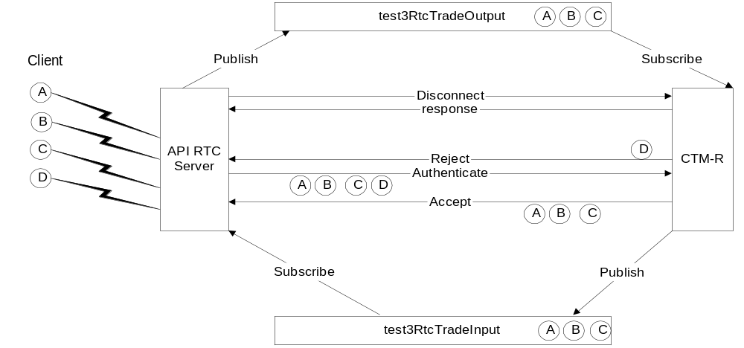

Notes:
- Client or firms are A to D.
- API RTC Server is CTM-I
- CTM-R is the back-end application
- Infrastructure has two ways it can communicate, point to point CORBA calls or Event Channels

CTMI RTC Connection Service
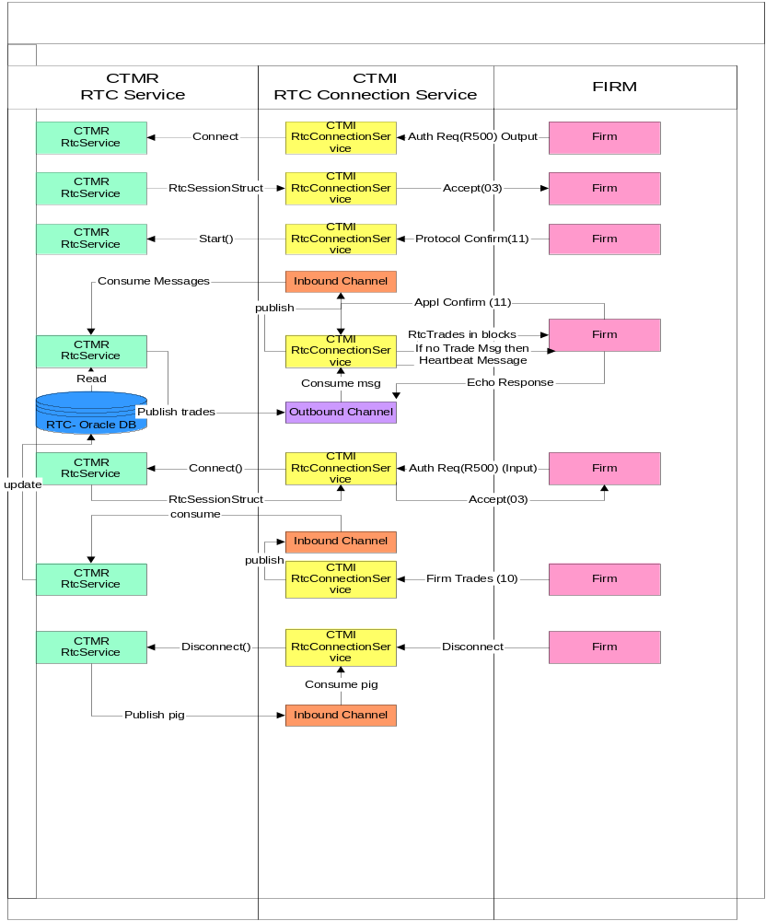

CTMI RTC Design
CTMI RTC Service essentially consists of two components:
- RTC Connection Service. This component is responsible for accepting one or more client/firm connections and servicing various the client/firm requests.
- The Event Channel Consumers (both Subscriber and Publisher). This component is responsible for consuming CTMR messages from outbound event channel (best effort) and publishing client/firm messages to the inbound event channel (GMD).

RTC Connection Service:
This comprises of the RtcConnectionServiceImpl class that implements the CBOE Direct’s
ConnectionService interface from Connection Server component and also implements
RtcTradeConsumerStub from the CTMR IDL class. This is depicted in the class diagram.

The RTC Connection Service Component has the following features:
- The component is designed as a server implementation of the ConnectionService interface waiting in a loop (listening) for incoming client connection requests.
- The service is started on Master mode and has the failover capability (how??).
- Whenever any client tries to connect to the RTC Connection Service its serve() method is called which dispatches the request to a method called handleMessage().
- In the handleMessage() method request is processed based on the type of request it received from the client (using a switch statement on Message type).
- The first thing the handleMessage() does is it tries to authenticate the client. If only authentication is successful it services the subsequent client requests.
- A sequence of handshake and messaging protocol requests is adhered to service client requests for trade messages from CTMI/CTMR. Client must send a protocol confirm message to the CTMI/CTMR to indicate that it is ready to receive trade messages.
- In absence of any further trade messages available in the event channel heartbeat messages are sent to clients and echo acknowledgement is received continuously.
- For every Trade message received from the CTMR (from Outbound Channel) if client has been setup with ‘Application Confirm’ option to Y, the client sends back an application confirm message either with a trade message appended to it or without the trade message appended.
- Step number 6 to 8 are related to the Output Service.
- Accept Pig Design Note: When firms disconnect, CTM-R’s disconnect will be called which in turn will do its own clean up operation and send a ‘Pig’ message to the Outbound Channel. CTM-I RTC Consumer’s ‘acceptPig(String origin)’ method will be fired. This will call CTM-I’s disconnectFirm() method which will do all cleanup operation on CTMI side like cleaning the Rtc Queue etc. and deregister the consumer from the Outbound Channel.
- For Input Service, after client authentication Client will send trade messages to CTMI/CTMR on its inbound channel.
- Event Channels QoS:
  - Outbound Event Channel – Best Effort
  - Inbound Event Channel – GMD
  - Both Inbound and Outbound Event Channel – Filtered
  - Message Ordering (both) – FIFO
- Filtering: Outbound Channel consumers are applied with acceptFirmTrade.tradeStruct.originName and acceptFirmTrade.tradeStruct.serviceType filters.

- RTC Connection Service is also provided with set of standard Admin Request (‘ar’) command that comes with CBOE Direct’s Connection Server implementation and a few custom ‘ar’ commands for Rtc Connection Service to identify which clients are connected to the Rtc Connection Service and disconnecting one or more clients if necessary.
- ShowRTCContext()
- ShowRTCQueueDepth
- DisconnectFirms
- DisconnectFirm
- StartRTC
- StopRTC

  - RTC Connection Service also provides an additional Method Instrumentor to acceptFirmTrade() method of the service to get message processing statistics.
- Method Instrumentor on acceptFirmTrade()

Event Channel Consumer:
This comprises of RtcTradeConsumerImpl class which implements CTMR IDL class POA_RtcTradeConsumer as depicted in the class diagram.

The features of the two RTC Event Channels are:
- Outbound Channel – for OUTPUT services. This is a Best Effort Channel. Messages are published onto this channel by CTMR and CTMI RTC Connection service is the consumer of the messages. It receives the trade messages from the channel and sends them to the appropriate client firm. Message blocking (number of messages to be sent to client) is handled by CTMI RTC Connection service. It does not maintain any state with regard to the messages sent out to the form after consuming from the event channel. If Application Confirm Messages are not received in the inbound channel from the client then messages are to be resent and state of the messages are to be appropriately managed by CTMR services.
- Inbound Channel – for INPUT Services. This is where Client firms send their trade messages (both application confirm as well as new trade messages). Rtc connection service is a publisher to this channel and CTMR is the consumer. CTMR would consume the messages and based on what is received would manage the state of trade messages on the backend.
- Event Channels QoS:
  - Inbound Event Channel – GMD
  - Outbound Event Channel – Best Effort
  - Both Inbound and Outbound Event Channel – Filtered
  - Message Ordering (both) – FIFO
- Filtering: Inbound Channel consumers are applied with acceptFirmTrade.tradeStruct.originName and acceptFirmTrade.tradeStruct.serviceType filters.

Processing Logic (End-to-end):

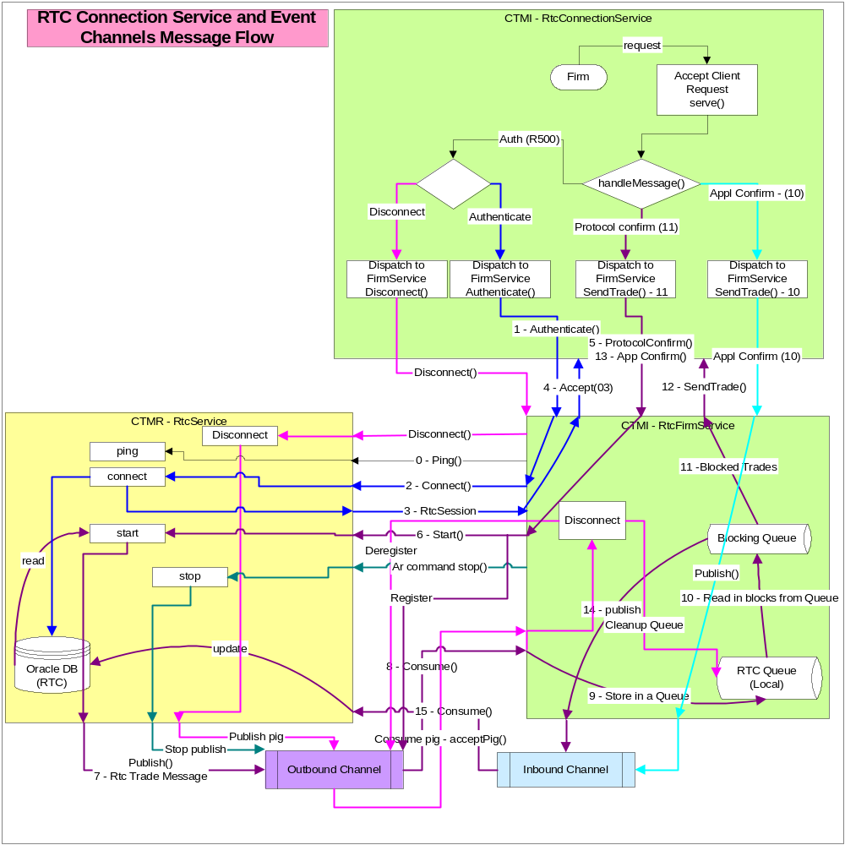
Fig 1: CTMI RTC Connection Service Module Message Processing Architecture and its interaction with CTMR module.

RTC Connection Service Design Model

Class Diagram:

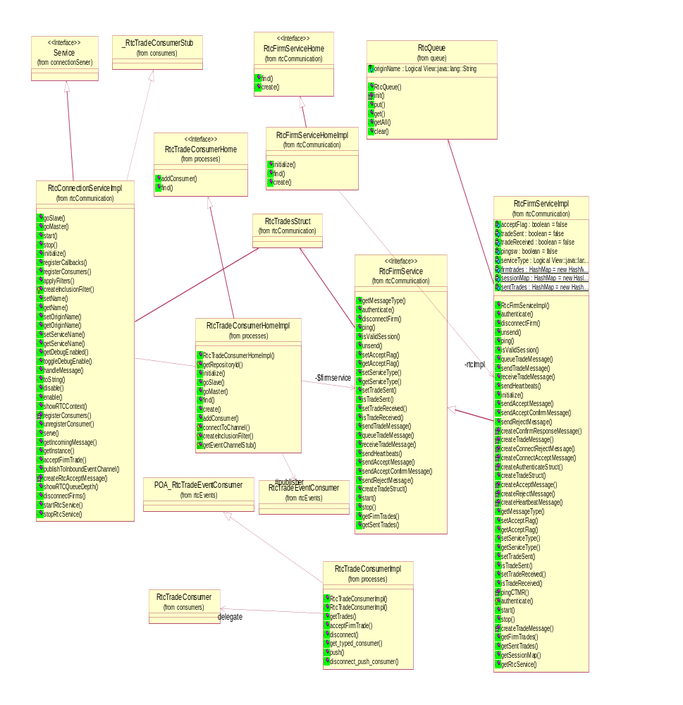

Class Diagram: RTC Connection Service Components

Sequence Diagram:
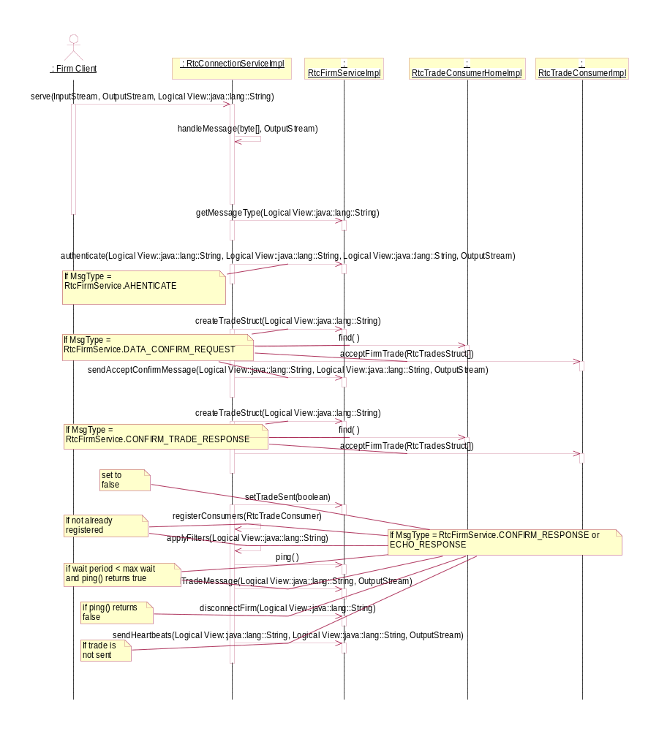

Sequence Diagram – Client Request to CTMI-RTC Connection Service

RTC Connection Service Implementation Model
The following classes constitute the Implementaion of the RTC Connection Service Module. This uses CBOE Direct’s ConnectionServer and Infrastructure EventChannels.
  - RtcConnectionServiceImpl
  - RtcFirmService
  - RtcFirmServiceImpl
  - RtcTradeConsumerImpl
  - RtcTradeConsumerHome
  - RtcTradeConsumerHomeImpl

RTC Connection Service Deployment Model
The Deployment Module consists of the following
- CTMI_RTC.jar
- setContext and setenv script file in bin dir.
- RtcConnectionService.xml, RtcConnectionService.dtd, RTCServer.xml, RTCserver.dtd and other associated xml and dtd files in xml and bin directory.
- Test Script files in bin directory
- Dependent Modules (?)

Server configuration options
Listed here are options needed in the server for optimal performance:
- Server shut down.
- In an event CTM-I would like to disallow clients from logging into the server, an option or switch or GUI parm value setting would need to be designed. This option would be for individual or global shut down.
- Audit log for message to and from CTM-I and CTM-R can be turned on or off.

Test Plan for RTC module

Test Environment and Setup:
- Select the host – ctmdev3
- Select an instance – ctmirtc09
- Deploy RTC modules using deployment script on instance 09
- Start the RTC Server and check it is in service using ‘chk’ utility.
- Two Alternatives for Testing
- Using Telnet service from clients
- Using Firm Simulators for CTMI
- Using Telnet service from clients
- Start a first Telnet Session1 on ctmdev3 at port 30109
- Start a second Telnet Session2 on ctmdev3 at port 30107
- Start a third Telnet Session3 on ctmdev3 at port 30109
- Using Firm Simulators for CTMI

Test Plan:

Test Cases:

1.01 Test For Authentication
  - Output Authentication
Open up a telnet session connecting to port where RTC Server is running. Copy and
paste the string:
“R500,0000CTMI PASSWORD RTCOUTPT A Y “ on the telnet terminal.
Expect result:
An accept message appearing on the telnet screen: “0030030000CTMIPASSWORDRTCOUTPT”

  - Input Authentication
Open up a separate telnet session connecting to port where RTC Server is running. Copy and paste the string:
“R500,0000CTMI PASSWORD RTCINPUT A Y “ on the telnet terminal.
Expected results:
An accept message appearing on the telnet screen: “0030030000CTMIPASSWORDRTCINPUT”

1.02 Test For CTMR ping()
- As soon as the RTC server is started, CTMR ping() method is called and if the ping() method fails the RTC Server stops.

1.03 Test for Ping() every <<TIME_INTERVAL>> minutes
- Thereafter CTMR ping() method is called at certain interval to ensure connectivity.
- See messages in the RTCServer.log to verify that the ping() method is successful.

1.04 Test for Output Protocol Confirm
- Copy and Paste the string “0030110000CTMIPASSWORDRTCOUTPT” on the same telnet terminal. You would not see any change at this point.
- Start publishing some trade messages in the Outbound Channel using the rtcintest0000 script in the bin directory connecting to Pankaj’s Input RtcService (temporarily for now until CMR is ready with publishing to this channel).
- You should see a number of messages appearing in the telnet terminal. These messages would be in blocks if there up to the maximum value of the blocking factor for that socket or less than the blocking factor depending on the number of message on the event channel.
- Repeat step 2 and you will receive trade messages appearing on the telnet terminal as long as there are messages in the output Event Channel.

Test for publishing trade messages to the Input Event Channel
- In the step c (Test 1.04) you should watch on the message monitor window’s Inbound Event Channel Message Count is increasing.
- Repeat test 1.04 as necessary to see the above effect.

1.06 Test for consuming trade messages from the Output Event Channel
- Same as test 1.04 above. (Repeat them as necessary)

1.07 Test for sending Heartbeat Messages to the Firm
- After all messages in the Event Channel are consumed wait for a minute and see Heartbeat message appearing on the telnet terminal.
- After Heartbeat message appears on the Telnet terminal copy and paste the Echo Response message “0030130000CTMIPASSWORDRTCOUTPT”. After a minute interval you will see the Heartbeat message again.

1.08 Test for receiving ECHO messages from the Firm
- Same as Test 1.07, step b.

1.09 Test for sending trade messages to the Firm
- Same as test 1.04 above. The messages appearing on the telnet terminal are the messages received by the Firm.

1.10 Test for receiving trade confirmation message from the Firm on the Input Channel
- Open up a separate telnet session connecting to port where RTC Server is running.
- Open up a MessageMonitor on the designated input Channel.
- Copy and paste the string “R500,0000CTMI PASSWORD RTCINPUT A Y “ on the telnet terminal.
- You receive an accept message appearing on the telnet screen like “0030030000CTMIPASSWORDRTCINPUT”
- After you receive accept message as above send a trade message of type 10 (copy and paste a trade message).
- See Messages appearing in the Channel.

Test for Output Event Channel Filtering with multiple clients connected to RTC
Service.
- Same as Test 1.04, from step b but with a messages for different clients (script: rtcintest0001 instead of rtcintest0000).
- You should not see any messages in the telnet terminal or in the Inbound Channel. Messages are not consumed from the Outbound Channel either. (See them in Message Monitor).
- In step a change the script to rtcintest0000 (client0000) and repeat the test. You should see messages consumed from the outbound channel and appearing in the telnet window and getting published in the Inbound Channel.

Test for Guaranteed Message Delivery (GMD) on Input Channel
  - Open up two or more telnet session connecting to the same port where RTC Service is

1.13 Test for multiple client connections to the RTC.
- Open up two or more telnet session connecting to the same port where RTC Service is running.
- Authenticate with different Authenticate String (Sysid, password).
- Copy and paste Protocol Confirm (type 11) on the Terminal.
- See all connections remain connected to the server.
- Apply protocol confirm on each of the terminal as it was done in step 1.04.
- Publish different client/firm messages on the Outbound Channel by running script rtcintest0000 to rtcintest0003.
- Observe that only the appropriate firm’s messages appear on the Telnet console.

1.14 Test for disconnecting one or more clients from the RTC.
- Try disconnecting one or more telnet clients and see log for the disconnecting firms and clean up messages.

1.15 Test for ‘ar’ command
- ShowRTCContext
ar RTCServer showRTCContext
Typical Output from the execution of the ‘ar’ command showRTCContext:

ctmdev3.cboe.com /ctmi/test/ctmirtc/ctmirtc09/run_dir/bin $ ar RTCServer showRTCContext

WARNING: Options file <cboe.ssconfig.cm> not found.
Found target service, getting command
Invoke RTCServer.showRTCContext( )
Result:
showRTCContext ::Origin/Service Name :0005CTMIRTCOUTPT(2)**Origin/Service Name :0000CTMIRTCOUTPT(1)**Origin/Service Name :0001CTMLRTCOUTPT(3)**

The following ‘ar’ command showContext as provided by the ConnectionService shows details of the Connections (with 2 firms connected as shown in bold).

ctmdev3.cboe.com /ctmi/test/ctmirtc/ctmirtc09/run_dir/bin $ ar RTCServer showContext

WARNING: Options file <cboe.ssconfig.cm> not found.
Found target service, getting command
Invoke RTCServer.showContext( "" )
Result:

------------------------------------------------------------------------
CONNECTIONS WILL NOT BE DROPPED WHEN RUNNING AS SLAVE.
------------------------------------------------------------------------

ServiceName/Type/Protocol/EnabledOnStart/CurrentlyEnabled: RtcConnectionService/Server/tcp/true/true
Service Impl : com.cboe.ctmi.rtcCommunication.RtcConnectionServiceImpl
Retry Count/Timeout : 3/5120
Configured Host and Port : Remote(null,-1)/Bind(170.137.230.44,30109)
Bind address reusable: false
Input/Output Buffer sizes: 32768/4096
Send/Recv Socket buffers : 1000000 /4096
Protocol InputQueue depth: -1
Connected Host and Port : ServerSocket[addr=/170.137.230.44,port=0,localport=30109]
Session manager : NONE SPECIFIED
Connection information : NO CONNECTION
Nbr clients connected : 2
RemoteClient(1):Socket[addr=170.137.79.213/170.137.79.213,port=4111,localport=30109], localhost=/170.137.230.44 (reuseAddr=false) - ConnectionNbr(5)
RemoteClient(2):Socket[addr=170.137.79.213/170.137.79.213,port=4123,localport=30109], localhost=/170.137.230.44 (reuseAddr=false) - ConnectionNbr(6)
Service Information:
debugEnabled = falsenull
-------------------------------------------------------------------------------------

- ShowRTCQueueDepth
ar RTCServer showRTCQueueDepth
- disconnectFirms
to be determined
- disconnectFirm
to be determined
- startRTC
to be determined
- stopRTC
to be determined

1.16 Test for ‘instrumentor’
- Run from the command line
$cmdConsUtil test3ctmirtc09ctmdev3 -port 19563 -host ctmdev3 –mi
- Open the MessageMonitor and open the instrumentor panel to observe the names of the instrumentor.
Method Instrumentor for RtcConnectionService:

Typical Output from the excution of the ‘cmdConsUtil’ command on Method Instrumentor
(he one in bold is added by RtcConnectionService in acceptFirmTrade() method. The others are the default instrumentors provided by the Infrastructure.)

$ cmdConsUtil test3ctmirtc09ctmdev3 -port 19563 -host ctmdev3 -mi
Status display for ORB(test3ctmirtc09ctmdev3,ctmdev3,19563) freeMem(24680808):

POAName POAState MaxThreads AvailThrds QSize
---------------------------- ---------- ---------- ---------- ----------
/ ACTIVE 5 5 0
/UserPOA ACTIVE 5 5 0
/AMIHandlerPOA ACTIVE 5 5 0
/test3InstrumentationChannel ACTIVE 1 1 0
/test3RtcTradeOutput ACTIVE 1 1 0
/CommandConsole ACTIVE 5 4 0

MethodInstrumentors(name,private,calls,excepts,methodtime,sumsq,maxtime,userdata):

POAQ/test3RtcTradeOutput/poaQLock,false,801,0,4341272.0,2.934681084E10,33550,null
POAQ/RootPOA/invoke,false,0,0,0.0,0.0,0,null
POAQ/test3RtcTradeOutput/transportToPoaQ,false,801,0,5.35926128E8,6.584449819858472E15,78296936,null
POAQ/test3RtcTradeOutput/invoke,false,801,0,4.13382484E8,2.156823113905296E15,42269402,null
myMIInstrumentor,false,221,0,8.1352172E7,1.007548184690624E15,31337400,null
POAQ/RootPOA/transportToPoaQ,false,0,0,0.0,0.0,0,null
POAQ/test3InstrumentationChannel/invoke,false,0,0,0.0,0.0,0,null
POAQ/CommandConsole/invoke,false,20,0,2.062734E7,1.23815767491048E14,8036820,null
POAQ/test3RtcTradeOutput/poaQ,false,801,0,1.34774783E9,9.12758113779114E15,43565934,null
POAQ/AMIHandlerPOA/invoke,false,0,0,0.0,0.0,0,null
POAQ/UserPOA/poaQLock,false,0,0,0.0,0.0,0,null
POAQ/AMIHandlerPOA/poaQLock,false,0,0,0.0,0.0,0,null
POAQ/UserPOA/invoke,false,0,0,0.0,0.0,0,null
POAQ/test3InstrumentationChannel/poaQ,false,1,0,330624.0,1.09312229376E11,330624,null
POAQ/RootPOA/poaQ,false,0,0,0.0,0.0,0,null
POAQ/UserPOA/poaQ,false,0,0,0.0,0.0,0,null
POAQ/RootPOA/poaQLock,false,0,0,0.0,0.0,0,null
POAQ/CommandConsole/poaQLock,false,21,0,112188.0,6.09302536E8,7418,null
POAQ/AMIHandlerPOA/poaQ,false,0,0,0.0,0.0,0,null
POAQ/CommandConsole/transportToPoaQ,false,21,0,4951318.0,1.221676879812E12,362098,null
POAQ/test3InstrumentationChannel/transportToPoaQ,false,1,0,4.86229879181568E15,7.3977263357325476E18,4862298791815680,null
POAQ/AMIHandlerPOA/transportToPoaQ,false,0,0,0.0,0.0,0,null
POAQ/CommandConsole/poaQ,false,21,0,1666172.0,1.40358910184E11,132184,null
POAQ/test3InstrumentationChannel/poaQLock,false,1,0,19370.0,3.751969E8,19370,null
POAQ/UserPOA/transportToPoaQ,false,0,0,0.0,0.0,0,null

Test with Simulator:
- Start Pankaj’s RTC Server to publish trades to Outbound Channel.
- Start Anant’s RTC Server to consume messages from Outbound Channel
- Populate Outbound Channel with Trade messages using RTC Input Simulator (rtcintest0000 / rtcintest0001 / rtcintest0002).
- Start RTC Output Simulator (rtcouttest0000 / rtcouttest0001 / rtcouttest0002) to get messages from the Outbound Channel.
- Observe messages (Type 10) being read from the queue transmitted to the Firm as long as there are messages in the Outbound Channel / Queue.
- Firms send out ACK messages (Type 11) with trade messages appended for each of these Trade messages. These messages are published on the Inbound Channel.
- If there are no more messages for 60 seconds a Heartbeat messages (Type 12) are sent to the firm for which Firms send back ECHO Response Message (Type 13) back to the RTC.

